CHAPTER ONE – GENERAL INTRODUCTION
1.1 Introduction
Digital platforms are now primary intermediaries between service providers and consumers across the global economy. In developing economies, this digital shift carries particular significance, offering the potential to organize and formalize labor exchanges that have historically depended on informal networks, geographic proximity, and word-of-mouth referrals. This project introduces GigGle, a web-based gig labor platform designed specifically for the Cameroonian urban context, connecting informal workers with individuals and households seeking short-term task assistance.
GigGle is built on four core value propositions: a digital reputation system to build verifiable trust between strangers, geographic radius filtering to surface contextually relevant job listings, integrated real-time messaging to centralize coordination, and a mobile money payment acknowledgment process aligned with Cameroon's dominant financial infrastructure. Together, these features provide the digital backbone for a labor exchange that Cameroonians already participate in offline, but have lacked the structured, scalable tools to conduct efficiently at scale.
1.2 Background of the Study
Digital platforms have become vital lifelines for students, retirees, and those seeking supplementary income. Within developing economies, this digital shift is especially critical, serving as a bridge between rigid formal employment and the often-unreliable informal daily wage sector.
In Cameroon, the labor market faces a dual crisis of unemployment and chronic underemployment. National data from the Institut National de la Statistique (INS, 2020) indicates a 6.4% unemployment rate, but the more telling figure is the 75% underemployment rate in urban centers like Douala, Yaoundé, and Bafoussam. Youth aged 15–35, who make up over 60% of the population, are disproportionately affected. Finding daily work remains a matter of luck making calls, roaming neighborhoods, relying on rumors, or hoping a WhatsApp group post bears fruit.
Simultaneously, middle-class urbanites seek domestic and technical help but lack reliable ways to identify and vet service providers. This mismatch — a large workforce on one side and high service demand on the other — persists despite mobile phone penetration exceeding 80% and mobile money services like MTN MoMo and Orange Money reaching over 12 million users (BEAC, 2021). The existing digital infrastructure has not been organized into a tool for local labor market coordination. GigGle addresses precisely this gap.
Example global platforms such as Fiverr and TaskRabbit, while successful in high-income markets, fail to address the Cameroonian context because they anchor payments to credit cards and international bank transfers that most local users cannot access. GigGle is designed to succeed where these platforms fail, by integrating mobile money, optimizing for low-bandwidth conditions, and building trust mechanisms appropriate to the local social and economic context.
1.3 Problem Statement
In many Cameroonian communities, individuals seeking short-term or flexible employment struggle to find accessible, reliable, and timely job opportunities, while businesses and individuals needing temporary labor lack an efficient way to connect with qualified, available workers. Existing job platforms focus predominantly on full-time or long-term roles, leaving the market for on-demand, short-term gigs fragmented, inefficient, and largely offline.
This mismatch results in lost income for workers, unmet labor needs for employers, and a general lack of trust, transparency, and convenience in securing or filling short-term engagements.
1.4 Objectives of the Study (General and Specific Objectives)
General Objective
To design and develop a centralized digital marketplace that connects individuals and businesses seeking short-term labor with qualified workers available for on-demand jobs, thereby eliminating market fragmentation, reducing inefficiencies in job discovery and fulfillment, and creating a trusted, transparent, and seamless experience for both parties.
Specific Objectives
- To build the platform's core engine including dynamic profile management for both job seekers and job posters, location-aware job browsing with radius filtering, and direct worker-to-employer messaging.
- To implement a transparent rating and review system that enables digital trust between transacting strangers.
- To build a secure payment acknowledgment gateway using mobile money providers MTN MoMo and Orange Money through the Notch Pay and CamPay APIs.
- To establish an administrator dashboard for handling users,user disputes and complaints and maintaining platform integrity.
1.5 Significance of the Study
This project offers tangible value across several dimensions of society:
- For Workers: GigGle provides a digital resume that is permanently accessible. A student can build a five-star rating record that makes them more discoverable and credible to prospective employers than informal referrals alone.
- For Employers: The platform offers peace of mind through verified reputations. Users can review a worker's rating history, skills, and prior job feedback before making contact.
- For the Economy: By moving informal transactions onto a structured digital platform, GigGle helps surface economic activity that is currently invisible to data collection, providing inputs for future urban planning and labor policy.
- For Academics: The project provides a blueprint for technology localization in developing economies. Most digital platform research focuses on high-income, high-infrastructure markets. This study explores how technology can adapt to the African, Cameroon socioeconomic context.
- For the University: The project demonstrates that software engineering students at LMUI can build locally relevant, technically sound platforms using modern development methodologies and tools.
1.6 Scope of the Study
GigGle is scoped to manage the complete lifecycle of a short-term gig from initial job posting to post-completion rating. The platform targets three specific user groups Workers, Employers, and Administrators — and focuses geographically on major urban centers including Douala, Yaoundé, Bafoussam, and Bamenda. The system covers short-term job categories (not exceeding six months) such as cleaning, tutoring, repairs, caregiving, delivery, event labor, and digital services.
The platform does not handle long-term corporate hiring, payroll management, tax-related employment compliance, or direct banking API integrations. Payment processing is modeled through a reference-code acknowledgment workflow in the MVP, with automated escrow integration identified as a post-MVP enhancement.
1.7 Definition of Terms
The following terms are used throughout this report with the meanings defined below:
- Gig: A short-term, task-based work assignment paid per job rather than through ongoing employment.
- Worker: A platform user who registers to offer services and accept job assignments.
- Employer: A platform user who posts job listings and hires workers for specific tasks.
- Mobile Money (MoMo): A digital payment service allowing financial transactions via mobile phone without a bank account; MTN MoMo and Orange Money are the primary providers in Cameroon.
- Reputation System: A platform feature that aggregates ratings and reviews to produce a visible trust score for each user based on past transaction performance.
- Geographic Filtering: A search mechanism that surfaces job listings within a specified distance from the user's location using GPS coordinates.
- Row Level Security (RLS): A database security model in which each database row is protected by policies defining which users may read or write it.
- Role-Based Access Control (RBAC): A security model that restricts system functionality based on the authenticated user's assigned role.
- Progressive Web Application (PWA): A web application that delivers app-like functionality including offline access and installability through modern browser features.
- Supabase: An open-source backend platform providing a managed PostgreSQL database, authentication, real-time subscriptions, and file storage.
- Sprint: A time-boxed development iteration in the Agile Scrum methodology, typically one to four weeks, producing a functional and testable increment.
- Escrow: A financial arrangement in which a third party holds payment funds until agreed conditions are met by both transacting parties.
1.8 Organization of the Study
This report is structured into five chapters:
- Chapter One introduces the problem context, study background, problem statement, objectives, significance, scope, and key terminology.
- Chapter Two reviews existing literature on digital labor platforms, gig economies, mobile money, and related theoretical frameworks; surveys prior systems; and proposes the GigGle system architecture.
- Chapter Three details the development methodology, hardware and software requirements, system modules, functional and non-functional analysis, and full system design including UML diagrams and data dictionary.
- Chapter Four presents implementation logic, test scenarios, results, and system demonstration screenshots.
- Chapter Five summarizes findings, draws conclusions, offers recommendations, and outlines perspectives for further study.
CHAPTER TWO – LITERATURE REVIEW
2.1 Introduction
This chapter critically examines existing models, frameworks, and implementations pertinent to digital gig labor platforms in developing economies with a particular focus on the Cameroonian context. It identifies conceptual foundations relevant to GigGle's design, surveys prior systems and their limitations, and underscores the gaps that our proposed solution addresses. The review draws from peer-reviewed literature, empirical studies, and documented platform analyses spanning the fields of information systems, labor economics, mobile money, and platform design.
2.2 Review of Related Concepts / Conceptual Framework
2.2.1 The Gig Economy and Digital Labor Platforms
The gig economy refers to a labor market characterized by short-term, flexible, task-based work arrangements where individuals are paid per assignment rather than through traditional employment contracts. Digital labor platforms serve as an intermediary matching layer that connects supply with demand in near real time. Global examples such as TaskRabbit, Fiverr, and Uber have demonstrated that this model can scale efficiently when enabling conditions — connectivity, digital payment infrastructure, and user trust — are present (De Stefano, 2016).
In the African context, the gig economy is not a new phenomenon; it is the digitization of an informal sector that has always existed. What GigGle introduces is bringing that informal economy onto a structured platform where transactions are recorded, reputations are tracked, and payments are acknowledged. This aligns with findings from Lehdonvirta (2019) that platforms in developing markets succeed primarily when they build on existing informal labor practices rather than attempting to replace them with foreign models.
2.2.2 Informal Labor Markets in Sub-Saharan Africa
The informal labor market across Sub-Saharan Africa is not a marginal phenomenon; it is the dominant economic reality. According to the International Labour Organization (ILO, 2018), informal employment accounts for over 85% of total employment in Africa south of the Sahara, with most workers engaged in casual or daily-wage arrangements without formal contracts, social protection, or legal recognition. In Cameroon specifically, urban underemployment stands at approximately 75%, with most youth surviving through odd jobs found through personal networks.
These markets operate on social trust rather than institutional trust. A worker finds a job because a neighbor recommended them, or because they are a familiar face in a neighborhood. This system is geographically constrained, exclusionary to outsiders, and provides no legal protection to either party in a dispute. GigGle's core value proposition is to digitize this trust layer, making it possible for strangers to transact with confidence where formal legal enforcement mechanisms are weak.
2.2.3 Digital Trust and Reputation Systems
Trust is the central problem in any marketplace, especially when parties are strangers with no institutional backing. Reputation systems aggregate past behavioral data — ratings, reviews, completion rates — and make them visible to future transacting partners. This converts accumulated trust into a searchable credential that helps users make informed decisions (Resnick 2000).
In Cameroon's informal sector, a digital reputation system can substitute for word-of-mouth networks that currently gatekeep access to work. A student who consistently delivers quality service can develop a verified track record visible to any employer on the platform, regardless of social connections. Research confirms that visible reputation metrics significantly increase transaction rates and reduce pre-transaction uncertainty. GigGle's rating system is built on this principle.
2.2.4 Mobile Money as a Payment Infrastructure for the Informal Sector
Mobile money dominates digital commerce in Cameroon, with over 12 million active users as of 2021 (BEAC, 2021). MTN MoMo and Orange Money process the vast majority of informal digital transactions. This means that many workers and employers who cannot access credit cards or traditional bank accounts are already participating in the digital financial system.
Jack and Suri's landmark research on M-Pesa in Kenya (2011) demonstrated that mobile money can functionally replace banking infrastructure and substantially reduce cash-based commerce risks. While Cameroon differs contextually, the underlying logic is directly applicable: high mobile money penetration provides a ready foundation for digital platform transactions. For GigGle, mobile money integration through Notch Pay and CamPay is therefore not an optional feature but a prerequisite for the platform to function for its target population.
2.2.5 Hyperlocal Platforms and Geographic Filtering
Hyperlocal platforms specifically aggregate supply and demand within a defined geographic radius, making them particularly well-suited to urban informal labor markets where physical proximity between worker and employer is often operationally necessary. Geographic filtering leverages device GPS data to surface the most relevant job listings for each worker based on their current or stored location.
Research on African urban informal labor (Muggah & Diniz, 2018) identifies geographic fragmentation as a primary barrier to market efficiency: workers and employers who are physically proximate often cannot find each other because they operate within different social networks. Geographic radius filtering directly reduces this friction, expanding each worker's effective market beyond their immediate social circle.
2.3 Review of Related Works
The following section reviews at least five prior systems relevant to GigGle's design. For each, the author(s), technology used, key strengths, and limitations are documented.
2.3.1 Jumia Jobs (Previously Hellojobs Cameroon)
Author(s)/Year: Jumia Group, launched in Cameroon approximately 2015.
Technology: Web portal backed by a relational database; mobile-optimized frontend.
Strengths: Provided a centralized job listing portal accessible to Cameroonian users; offered category filtering and application submission.
Limitations: Focused primarily on formal employment and professional roles; payment processing not integrated; no reputation system for workers; geographic filtering limited. The platform was eventually discontinued in many African markets, suggesting its formal employment model was misaligned with local labor market realities.
2.3.2 TaskRabbit (International Platform)
Author(s)/Year: Leah Busque, founded 2008 (United States).
Technology: React Native mobile applications; Node.js backend; Stripe payment processing.
Strengths: Mature, scalable platform with a robust reputation system; geographic matching; in-app payment escrow; category-based task filtering.
Limitations: Inaccessible to the vast majority of Cameroonian users due to credit card payment requirements; no mobile money integration; designed for high-income markets with stable broadband; interface assumes high digital literacy. Cultural and linguistic fit is poor for Francophone and Pidgin-speaking Cameroonian users.
2.3.3 Fiverr (International Platform)
Author(s)/Year: Micha Kaufman and Shai Wininger, founded 2010 (Israel).
Technology: React frontend; microservices backend; PayPal and credit card payments.
Strengths: Highly scalable global platform with strong reputation system; extensive category taxonomy; supports digital service delivery.
Limitations: Entirely inaccessible in Cameroon's informal sector context — requires bank accounts and credit cards; focused on remote digital services rather than physical local tasks; PayPal has limited availability in Cameroon; interface complexity excludes low-digital-literacy users.
2.3.4 Local WhatsApp Job Groups (Informal Digital Channels)
Author(s)/Year: Informal community administrators, major Cameroonian cities (ongoing).
Technology: WhatsApp messaging platform; no structured data layer.
Strengths: Highly accessible; zero cost to join; operates on existing mobile data; trusted within existing social networks; supports multimedia (photos, voice notes) for job descriptions.
Limitations: Zero dispute resolution mechanism; no payment protection or escrow; no reputation system — workers cannot build verifiable track records; job listings are ephemeral and unsearchable; geographic filtering absent; accessible only to those within existing social networks, reinforcing exclusion for newcomers.
2.3.5 Afriwork (Ethiopia)
Author(s)/Year: Frehiwot Tamiru, founded approximately 2019 (Ethiopia).
Technology: Telegram-based platform (with web component); Telegram bot API and channel
Strengths: Extremely high accessibility on low-end smartphones; zero-cost entry for freelancers; operates on unstable internet connections; large established user base in East Africa; proves demand for localized digital labor matching in African markets.
Limitations: No structured reputation system trust relies on screenshots with no aggregated permanent rating score; ephemeral job listings scroll away and become unsearchable; no geographic filtering for neighborhood-specific jobs; no structured application, selection, or payment acknowledgment workflow; no role-based separation between employers and workers, creating feed noise for both parties; no formal dispute resolution mechanism; coordination reverts to unmonitored direct messaging with no audit trail.

2.4 Data Collection Methods

A mixed-methods approach was employed. Semi-structured interviews were conducted with informal workers and sending out questionaires as well in Buea to surface pain points around job-seeking, vetting, payment disputes, and digital tool usage. Observational data was also gathered from interactions between friends and family during their job seeking periods. Secondary data was gathered from the Cameroon National Institute of Statistics, the Bank of Central African States, the ILO, and peer-reviewed literature on gig economies and mobile money in Sub-Saharan Africa.

2.5 Population and Sampling

The target population comprises informal workers (students, retirees, supplementary income earners) and casual employers (individuals and households) in Cameroonian urban centers. Purposive sampling was employed to select participants who could provide the most contextually relevant insights. For usability validation, a sample of approximately fifteen individuals representing both user roles was engaged during the testing phase of Sprint 4.

2.6 Proposed Solution
Building on the gaps identified across existing financial management and labor platform tools, this project proposes GigGle: a web-based digital marketplace for short-term gig labor tailored for the Cameroonian urban informal economy. The core objective is to eliminate the fragmentation, trust deficits, and payment insecurity that characterize informal labor coordination, while preserving the accessibility and mobile-first character of tools that Cameroonian workers already use.
2.6.1 System Architecture Overview
The proposed system adopts a three-tier client-server architecture:
- Presentation Layer (React.js + Tailwind CSS): Worker Portal for job browsing, application submission, messaging, and profile management; Employer Dashboard for job posting, applicant review, worker selection, job completion marking, and rating submission; Admin Console for user management, content moderation, platform analytics, and dispute resolution.
- Application Layer (Supabase + PostgREST + Supabase Realtime): Authentication and role-based access control via Supabase Auth with JWT tokens; REST and GraphQL APIs auto-generated by PostgREST from the PostgreSQL schema; real-time messaging via Supabase Realtime channel subscriptions.
- Data Layer (Supabase PostgreSQL + Row Level Security + Supabase Storage): Six-table normalized relational schema (users, profiles, jobs, applications, messages, ratings); RLS policies enforcing that users can only access records scoped to their own role and identity; file storage for profile images and verification documents.
CHAPTER THREE – MATERIALS AND METHODS USED
3.1 Introduction
This chapter outlines the research and development methodologies, tools, materials, and architectural design employed to design and implement GigGle a hybrid digital gig labor marketplace aligned with the objectives stated in Chapter One. It details the iterative development process, hardware and software requirements, system modules, functional and non-functional requirements, cost evaluation, project schedule, and full system design including UML models and data dictionary.
3.2 Development Methodology Used
3.2.1 Agile Scrum Implementation
This study adopts the Agile Software Development methodology, specifically the Scrum framework. Agile was selected because GigGle's development context demands flexibility to respond to user needs that cannot be fully anticipated at project outset. Development is structured across four primary sprints:
Sprint planning defined user stories and broke them into tasks including UI components, database schema, Supabase RLS policies, and API integration. Daily stand-ups maintained 15-minute progress syncs. Sprint reviews showcased completed features to simulated stakeholders. Retrospectives identified process improvements such as tightening RLS policy testing procedures.
3.3 Tools and Materials Used
3.3.1 Hardware Requirements
Devices used by end users:
- Workers: Any contemporary smartphone or desktop running Chrome, Firefox, or Edge with a stable mobile data or Wi-Fi connection. Minimum: dual-core processor, 2 GB RAM.
- Employers: Desktop or laptop computer with Chrome v100+ or Firefox v95+; minimum 4 GB RAM recommended for the employer dashboard interface.
- Administrators: Workstation with a modern browser, 8 GB RAM recommended for the analytics dashboard.
- Development Machine: Laptop with SSD, 8 GB RAM, Node.js environment, and Supabase CLI installed.
- Network: Stable HTTPS access to Supabase cloud services; minimum 5 Mbps recommended; platform is optimized for 3G performance.
3.3.2 Software Requirements
Operating systems: Windows 10/11, macOS 12+, or Ubuntu 22+ (development).
Browsers: Chrome v100+, Firefox v95+, Edge v100+.
Runtime and package management:
- Node.js v18.x LTS; npm v9.x or yarn v1.22.x.
- Vite v4.x for React application scaffolding and hot module replacement.
Libraries and Frameworks:
- Frontend: React 18, Tailwind CSS, React Router v6.
- State and Data: Supabase JavaScript Client v2 (Auth, Database, Realtime, Storage), TanStack Query for caching and background refetching.
- Geographic Features: Leaflet.js with OpenStreetMap tiles; PostGIS extension on Supabase PostgreSQL for coordinate-based radius queries.
- Form Handling: React Hook Form, Zod schema validation.
- UI Components: ShadCN/UI component library.
- Payment Integration: Notch Pay SDK and CamPay API for MTN MoMo and Orange Money payment acknowledgment.
CLI and DevOps:
- Supabase CLI v1.x for local development stack management.
- Git with GitHub for version control; Vercel for frontend deployment.
- Testing: Vitest and React Testing Library for unit and component tests.
3.4 System Modules
- Authentication and Role Management Module: Handles registration, login, session persistence, and role assignment. Supabase Auth manages JWT generation; role stored in profiles table and enforced by React Router protected routes.
- Job Listing and Browsing Engine: Employers create structured listings with category, description, pay, location, and timeline. Workers browse via a parameterized Supabase query using PostGIS radius calculations and category filters.
- Application and Selection Workflow: Manages the application lifecycle from submission through employer selection and automatic rejection of competing applications. Triggers the post-completion rating prompt.
- Real-Time Messaging System: Supabase Realtime channel per job_id scope. Messages persist in the messages table; new messages appear instantly in both parties' chat interfaces without page reload. Chat unlocked only after worker selection.
- Reputation and Rating System: Post-completion star ratings and optional text reviews from both parties. Aggregated into a running average displayed on public profiles. Rating submission blocked until job is confirmed complete.
- Administrator Dashboard Module: Provides tools for reviewing flagged content, suspending accounts, managing users, and viewing platform-level analytics including registration trends and job completion rates.
3.5 System Analysis
3.5.1 Functional Requirements
The following functional requirements define what the system must do:
- User Management: Workers self-register by selecting the Worker role and completing a profile. Employers self-register similarly. Administrators are assigned directly in the database.
- Job Posting and Browsing: Employers post gig listings with category, description, pay, and location. Workers browse listings filtered by geographic radius and category.
- Application and Selection: Workers apply for listings with a single action. Employers review applicant profiles and select one worker, automatically rejecting all others.
- Real-Time Messaging: Matched worker-employer pairs communicate via real-time chat scoped to the specific job.
- Job Completion and Rating: Employers confirm job completion, triggering a rating prompt for both parties.
- Administrator Controls: Admins can review reports, moderate content, suspend accounts, and view platform analytics.
- Payment Acknowledgment: Workers submit a mobile money reference code to acknowledge payment; employers confirm receipt.
3.5.2 Non-Functional Requirements
- Performance: Job browsing results returned within 2 seconds on a 3G connection. Real-time message delivery latency under 1 second in the local simulation environment.
- Scalability: Supabase's managed PostgreSQL with connection pooling supports growth from hundreds to tens of thousands of users without infrastructure changes.
- Security: HTTPS enforced; Supabase RLS policies prevent unauthorized data access at the database level; JWT tokens expire and are refreshed automatically.
- Usability: Responsive UI for smartphones and desktops; intuitive workflows requiring minimal training; Tailwind CSS ensures consistent visual hierarchy.
- Availability: Vercel's CDN-backed hosting targets 99.9% uptime; Supabase's managed infrastructure provides equivalent backend reliability.
- Data Integrity: Zod schema validation on all form inputs; Supabase database constraints enforce referential integrity.
3.5.3 Cost Evaluation
The table below presents the cost evaluation for GigGle, listing all key hardware and software components with quantities and unit prices in XAF.

Category | Component | Item | Qty | Unit Price (XAF)
Hardware | Laptop | Developer workstation (LENOVO i5, 8 GB RAM) | 1 | 150,000
Hardware | Smartphone | Mobile test device (Android) | 1 | 50,000
Hardware | Internet | Mobile data / Wi-Fi (monthly) | 3 | 15,000
Software | React.js | Frontend framework (open source) | — | 0
Software | Tailwind CSS | UI utility library (open source) | — | 0
Software | Supabase | Backend platform (free tier) | 1 | 0
Software | Vercel | Hosting (free tier) | — | 0
Software | Leaflet.js | Mapping library (open source) | — | 0
Software | VS Code | Code editor (free) | 1 | 0
Software | GitHub | Version control (free tier) | — | 0
Software | Vite | Build tool (open source) | — | 0
Software | CamPay | Payment API (free sandbox tier) | 1 | 0
Human Resource | Developer Time | Project development (4 sprints) | 1 | 0
 |  | TOTAL |  | 215000
Table 1: GigGle System Cost Evaluation
3.5.4 Project Schedule

Phase | Duration | Dates
Requirements and Design | 2 weeks | 2026-03-02 → 2026-03-15
Sprint 1: Auth and Profiles | 2 weeks | 22026-03-16 → 2026-03-29
Sprint 2: Core Job Loop | 3 weeks | 2026-03-30 → 2026-04-19
Sprint 3: Messaging and Ratings | 2 weeks | 2026-04-20 → 2026-05-03
Sprint 4: Testing and Deployment | 2 weeks | 2026-05-04 → 2026-05-17
Documentation and Report Writing | 3 weeks | 2026-05-18 → 2026-06-07
Table 2: GigGle Project Schedule

3.5.5 Use Case Analysis
Use case diagrams visually represent the system's functional requirements by showing how actors interact with it to achieve specific goals. GigGle has three primary actors: Worker, Employer, and Administrator. The diagram below show the associations and actor usecases
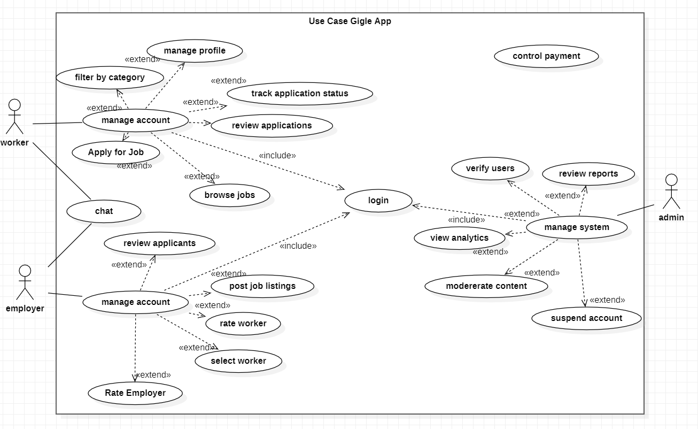
Figure 2: GigGle Use Case Diagram
3.5.6 Sequence Diagrams
Sequence diagrams illustrate how system components interact in time-ordered message sequences. They outline the step-by-step execution of key system operations.
(a) Job Posting and Application Flow: The Employer initiates by submitting a job creation form. The React frontend validates inputs client-side and calls the Supabase client insert method, transmitting data to the PostgREST API. PostgreSQL creates the job record and returns a success response. The Worker independently opens the job browsing screen, triggering a parameterized Supabase query filtered by coordinates and category. When the Worker submits an application, a new record is inserted into the applications table and the Employer is notified.
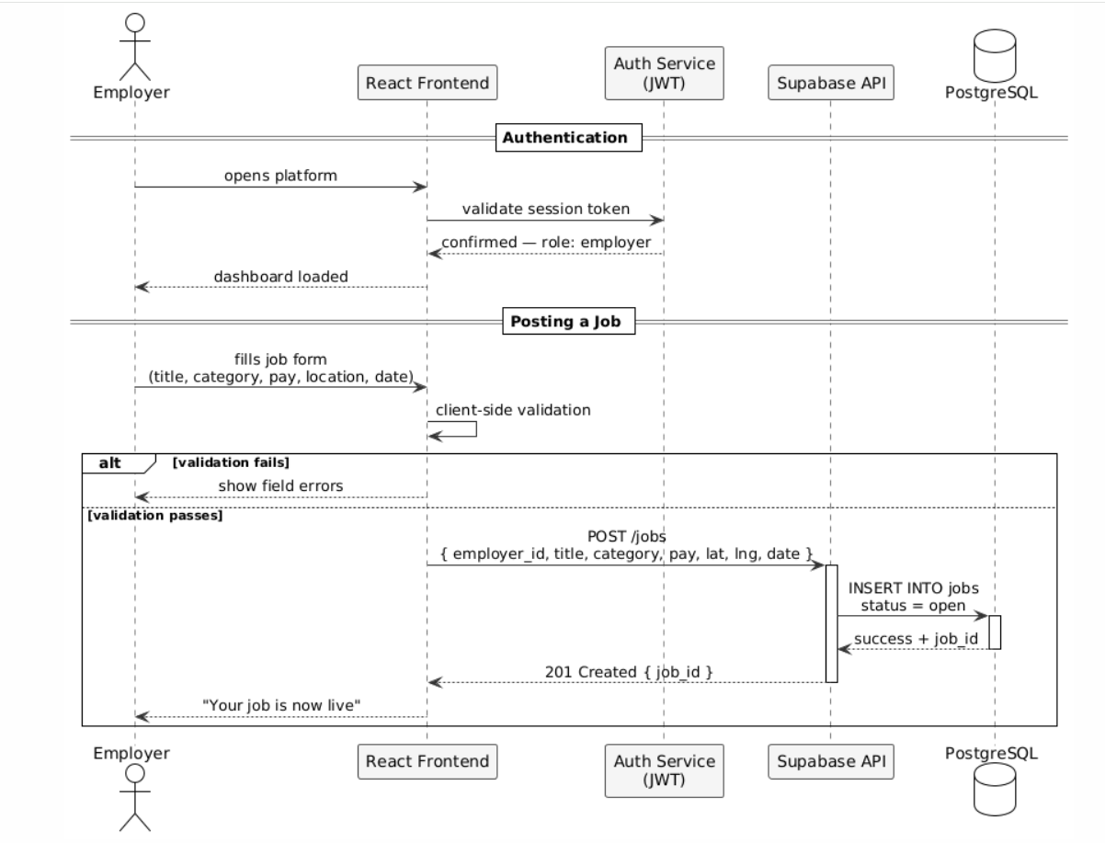
Figure 3: Sequence Diagram – Job Posting and Application Flow
(b) Registration and On-boarding: The new user opens the registration screen, selects a role, and submits email and password. Supabase Auth creates a user record and returns a JWT. A trigger creates the corresponding profile record in the profiles table with the selected role. React Router reads the role from the JWT and redirects to the appropriate dashboard.
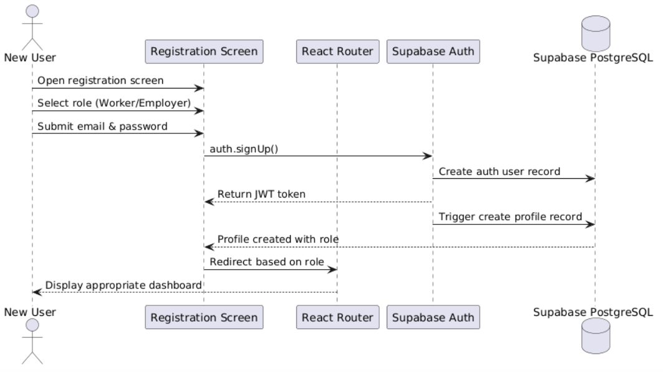
Figure 4: Student Registration and On-boarding Sequence Diagram
3.5.7 Activity Diagram
The activity diagram illustrates the complete workflow for the core gig lifecycle — from job posting through worker selection, job execution, and post-completion rating — capturing all decision points and parallel flows.
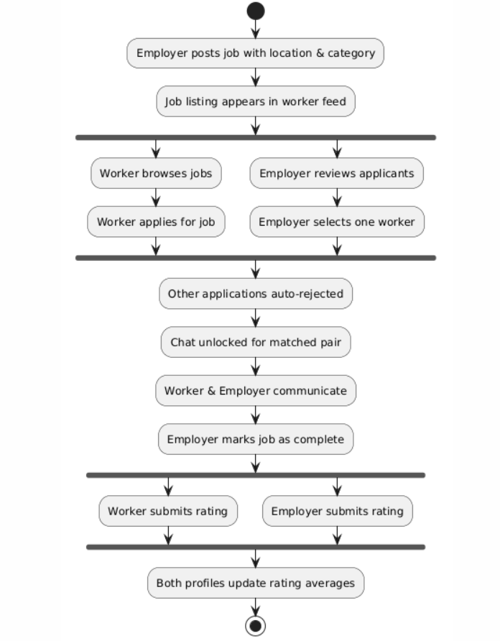
Figure 5: Activity Diagram – End-to-End Gig Lifecycle
3.6 System Design
This section presents the design architecture of GigGle, focusing on the system's structural layout, component interactions, and data flow between modules. The design adopts a three-tier architecture comprising the presentation layer, application logic layer, and data layer.
3.6.1 System/Network Architecture
GigGle is built on a client-server architecture in which a React.js single-page application running in the user's browser communicates with a Supabase backend over HTTPS. The architecture separates the presentation layer entirely from data management, allowing the frontend to be updated and deployed independently.
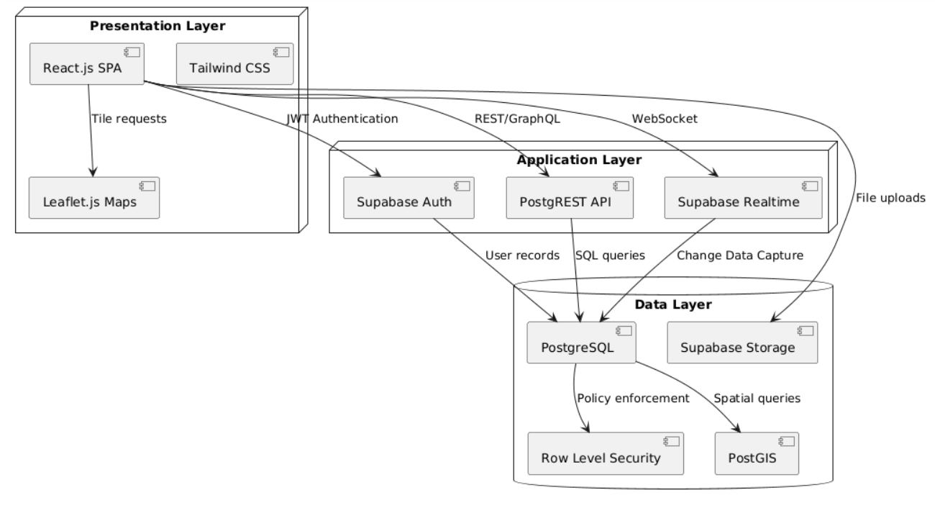
Figure 6: GigGle 3-Tier Architecture Diagram
3.6.3 Class Diagrams
Class diagrams represent the system's static structure by illustrating classes, their attributes, methods, and relationships. The User class is the base from which Worker and Employer inherit. The Job class contains a reference to the creating Employer. The Application class references both a Worker and a Job. The Message class is scoped to a Job. The Rating class references the rated User and the associated Job.
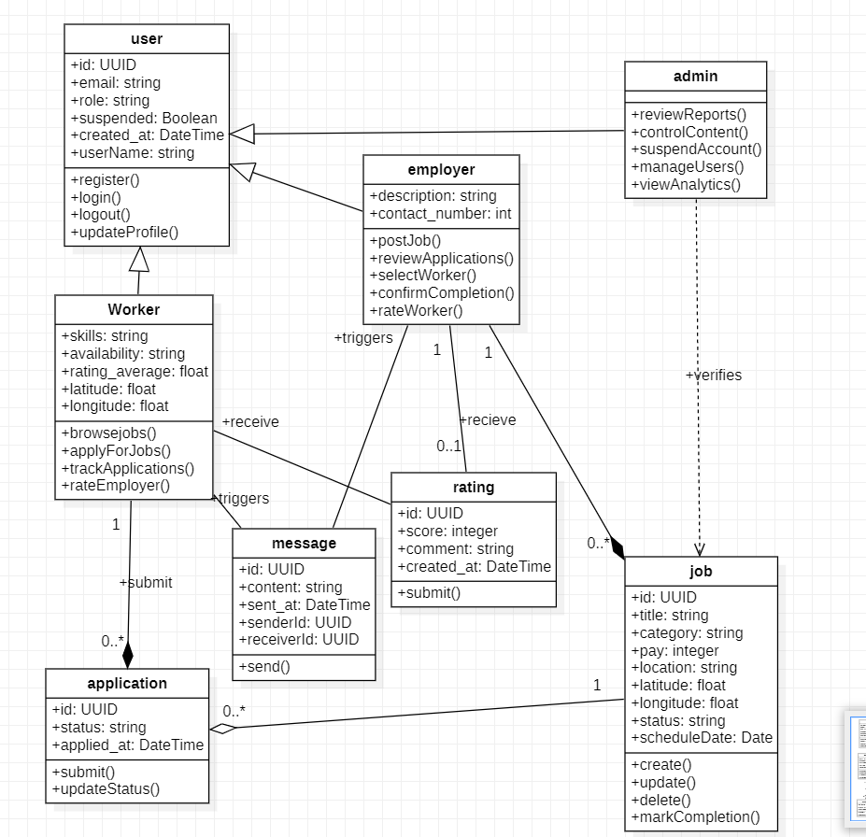
Figure 7: GigGle Class Diagram
3.6.4 Entity-Relationship Diagram
The Entity-Relationship Diagram shows the key entities and their relationships in the GigGle system. The USERS entity has a one-to-many relationship with JOBS (as employers) and APPLICATIONS (as workers). The JOBS entity has a one-to-many relationship with APPLICATIONS and MESSAGES. The RATINGS entity references both the rated USER and the associated JOB.
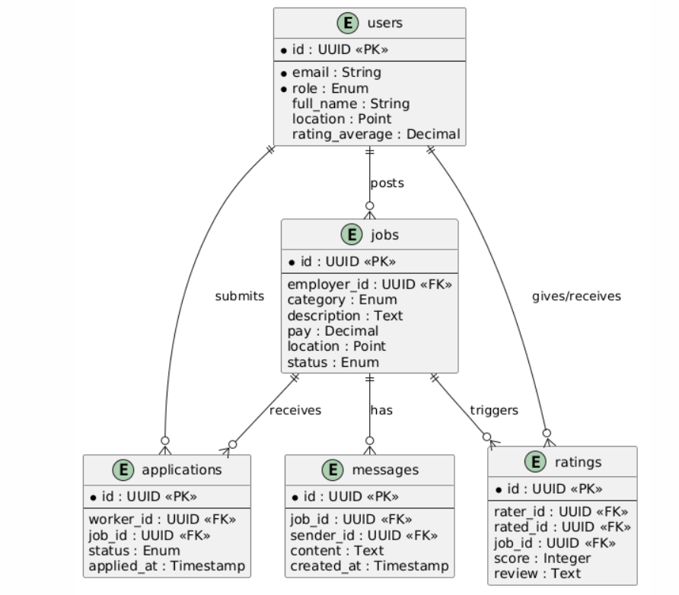
Figure 8: Entity-Relationship Diagram

3.6.5 Data Dictionary
Field Name | Data Type | Description | Constraints
id (user) | UUID | Unique identifier for each user | Auto-generated by Supabase Auth
email | String | User email address | Required; unique; valid email format
role | Enum | User role in the system | Values: 'worker', 'employer', 'admin'
full_name | String | User's full name | Required; alphabetic characters; max 100 chars
location | Point (PostGIS) | User's geographic coordinates | Stored as latitude/longitude pair
rating_average | Decimal | Aggregated rating score | Range 1.0–5.0; null until first rating received
job_id | UUID | Unique identifier for each job listing | Auto-generated; primary key of jobs table
category | Enum | Job service category | Values: cleaning, tutoring, repairs, delivery, etc.
status (job) | Enum | Current state of the job listing | Values: 'open', 'in_progress', 'completed', 'cancelled'
pay | Decimal (XAF) | Offered payment for the job | Must be > 0
application_id | UUID | Unique identifier for each application | Auto-generated; primary key of applications table
status (app) | Enum | Application state | Values: 'pending', 'accepted', 'rejected'
message_id | UUID | Unique message identifier | Auto-generated by database
content | Text | Message body | Required; max 2000 characters
rating_id | UUID | Unique rating identifier | Auto-generated by database
score | Integer | Star rating submitted | Range 1–5; required
reference_code | String | Mobile money transaction reference | Required; alphanumeric; max 30 chars
Table 3: GigGle Data Dictionary

CHAPTER FOUR – IMPLEMENTATION, RESULTS AND TESTING
4.1 Introduction
This chapter provides a comprehensive overview of the implementation of GigGle, presenting the technology stack integration details, user role implementation logic, key system component behaviors, and end-to-end simulation results. Testing strategies including unit, integration, and system testing are documented with test cases, acceptance criteria, and outcomes. Emphasis is placed on validating the four core value propositions of the platform: geographic filtering, real-time messaging, reputation building, and mobile money payment acknowledgment.
4.2 Implementation
4.2.1 Technology Stack Implementation
The GigGle platform was implemented using the following stack:
- Frontend: React 18 (scaffolded via Vite) with Tailwind CSS for responsive component rendering; React Router v6 for client-side navigation and route protection.
- Backend: Supabase platform providing managed PostgreSQL, auto-generated REST API via PostgREST, real-time subscriptions via Supabase Realtime, and file storage via Supabase Storage.
- Authentication: Supabase Auth with JWT tokens; role stored in profiles table and enforced by React Router protected route wrappers.
- Geographic Features: Leaflet.js with OpenStreetMap tiles for the interactive job map; PostGIS extension for coordinate-based radius filtering queries.
- Payment Integration: Notch Pay and CamPay sandbox APIs for MTN MoMo and Orange Money payment acknowledgment workflows.
- Hosting: Frontend deployed on Vercel; Supabase backend on Supabase's managed cloud. GitHub Actions configured for CI/CD on merge to main branch.
4.2.2 User Roles and Permissions
The system enforces Role-Based Access Control through Supabase Row Level Security policies combined with React Router protected routes. The roles are:
- Worker: Browse jobs, apply for listings, access accepted-job chat, submit post-completion ratings, view own profile and application history.
- Employer: Post and manage job listings, review applicants, select workers, access accepted-job chat, confirm job completion, submit post-completion ratings.
- Administrator: Access the admin dashboard for user management, content moderation, dispute review, and platform analytics. Admin accounts created directly in the database.
4.2.3 Geographic Filtering Implementation
Geographic filtering is implemented using a parameterized Supabase RPC (Remote Procedure Call) that calls a PostgreSQL function leveraging the PostGIS ST_DWithin function. The worker's stored coordinates and a configurable radius in kilometers are passed as parameters. The query returns all open job listings with employer locations within the specified radius, ordered by distance. This allows workers to see the most proximate relevant jobs first without requiring a full-table scan.
4.2.4 Real-Time Messaging Implementation
The messaging system uses Supabase Realtime channels scoped to each unique job_id to prevent message leakage between unrelated job conversations. When a worker is selected, both parties gain access to a dedicated chat screen. Messages are inserted into the messages table via the Supabase client, which triggers a real-time broadcast to all subscribers of that channel. The chat history is persistent and accessible throughout the job lifecycle. Supabase RLS policies enforce that only the worker and employer assigned to a specific job can read or write its messages.
4.2.5 Payment Acknowledgment Workflow
In the MVP, payment processing is modeled through a reference-code submission workflow. After job completion, the employer initiates payment via their mobile money provider (MTN MoMo or Orange Money) outside the platform. The employer then submits the transaction reference code through the GigGle interface. The system records this reference code against the job record and marks payment as acknowledged. Both parties are notified. This approach preserves the platform's value as a coordination and trust layer without requiring real-time API integration in the MVP, which is identified as a priority post-MVP enhancement.
4.2.6 Admin Dashboard Features
- User Management: View all registered users grouped by role; suspend or reinstate accounts.
- Content Moderation: Review and remove flagged job listings and profiles.
- Platform Analytics: Total registered users, active job listings, completed gigs, and application volumes by category.
- Dispute Review: Access reported interactions and take administrative action.

